Milestone 2 – SEPT

Group 4 – Jack Hollis-London, Jacob McEwan, Minggang Dong, Moritz Hauptmann

# Project Details

|  |  |
| --- | --- |
| Resource | URL |
| GitHub | <https://github.com/Someoneamzing/sept-group-assignment> |
| Jira | [septassignmentproject - Agile board - Jira (atlassian.net)](https://septassignmentproject.atlassian.net/jira/software/projects/SEP/boards/1/backlog) |
| CircleCI | <https://app.circleci.com/pipelines/github/Someoneamzing/sept-group-assignment?invite=true> |

# Contribution Peer Review

|  |  |  |
| --- | --- | --- |
| Person | Contribution % | Tasks Completed |
| Jack Hollis-London | 25% | * Implemented Continuous Integration using CircleCI * Implemented PBI SEP-10 Preview Books and Books for Sale * Implemented PIB SEP-22 User JWT login and authorization * Researched and tested Kubernetes deployments |
| Jacob McEwan | 25% | Wrote functionality for SEP 21 and SEP 7, Setup base code for book microservice and Order Microservice. |
| Minggang Dong | 25% | Wrote functionality for SEP-15, basic functionalities done for SEP-16 but no testing files. |
| Moritz Hauptmann | 25% | Wrote functionality and testing for SEP 26, setup basic routing and navigation for the landing page and contact us page. Started on SEP 17 to implement admin functionalities. |

# Continuous Integration Results

# a summary of new User Stories, new code and tests, new functionality (e.g., a list of new code/test files, names/numbers of user stories, a short description of new functionality)

## Implemented User Stories

|  |  |
| --- | --- |
| ID | Story |
| SEP-26 | As any type of user, I want to view Bookeroo's Home Page and Contact Us page so that I can take action |
| SEP-15 | As an unregistered user, I want immediate account registration so that I can become a user of bookeroo straight away |
| SEP-21 | As any user, I want to be able to add books, so that I can sell them. |
| SEP-22 | As a registered user, I want to login to bookeroo, so that I can use bookeroo's secured services |
| SEP-10 | As a user, I want to be able to see a preview of a book so that I can learn more about a book I'm interested in. |

## Added Functionality

This milestone has added the landing page, account registration for public users, adding books to sell, public user login and book previews.

# User Stories + Product Backlog in JIRA

[septassignmentproject - Agile board - Jira (atlassian.net)](https://septassignmentproject.atlassian.net/jira/software/projects/SEP/boards/1/backlog)

Screenshots of JIRA are available in the folder ‘Docs/Milestone 2/JIRA_screenshots/’

# Documentation of test cases and evidence/documentation of test execution and results

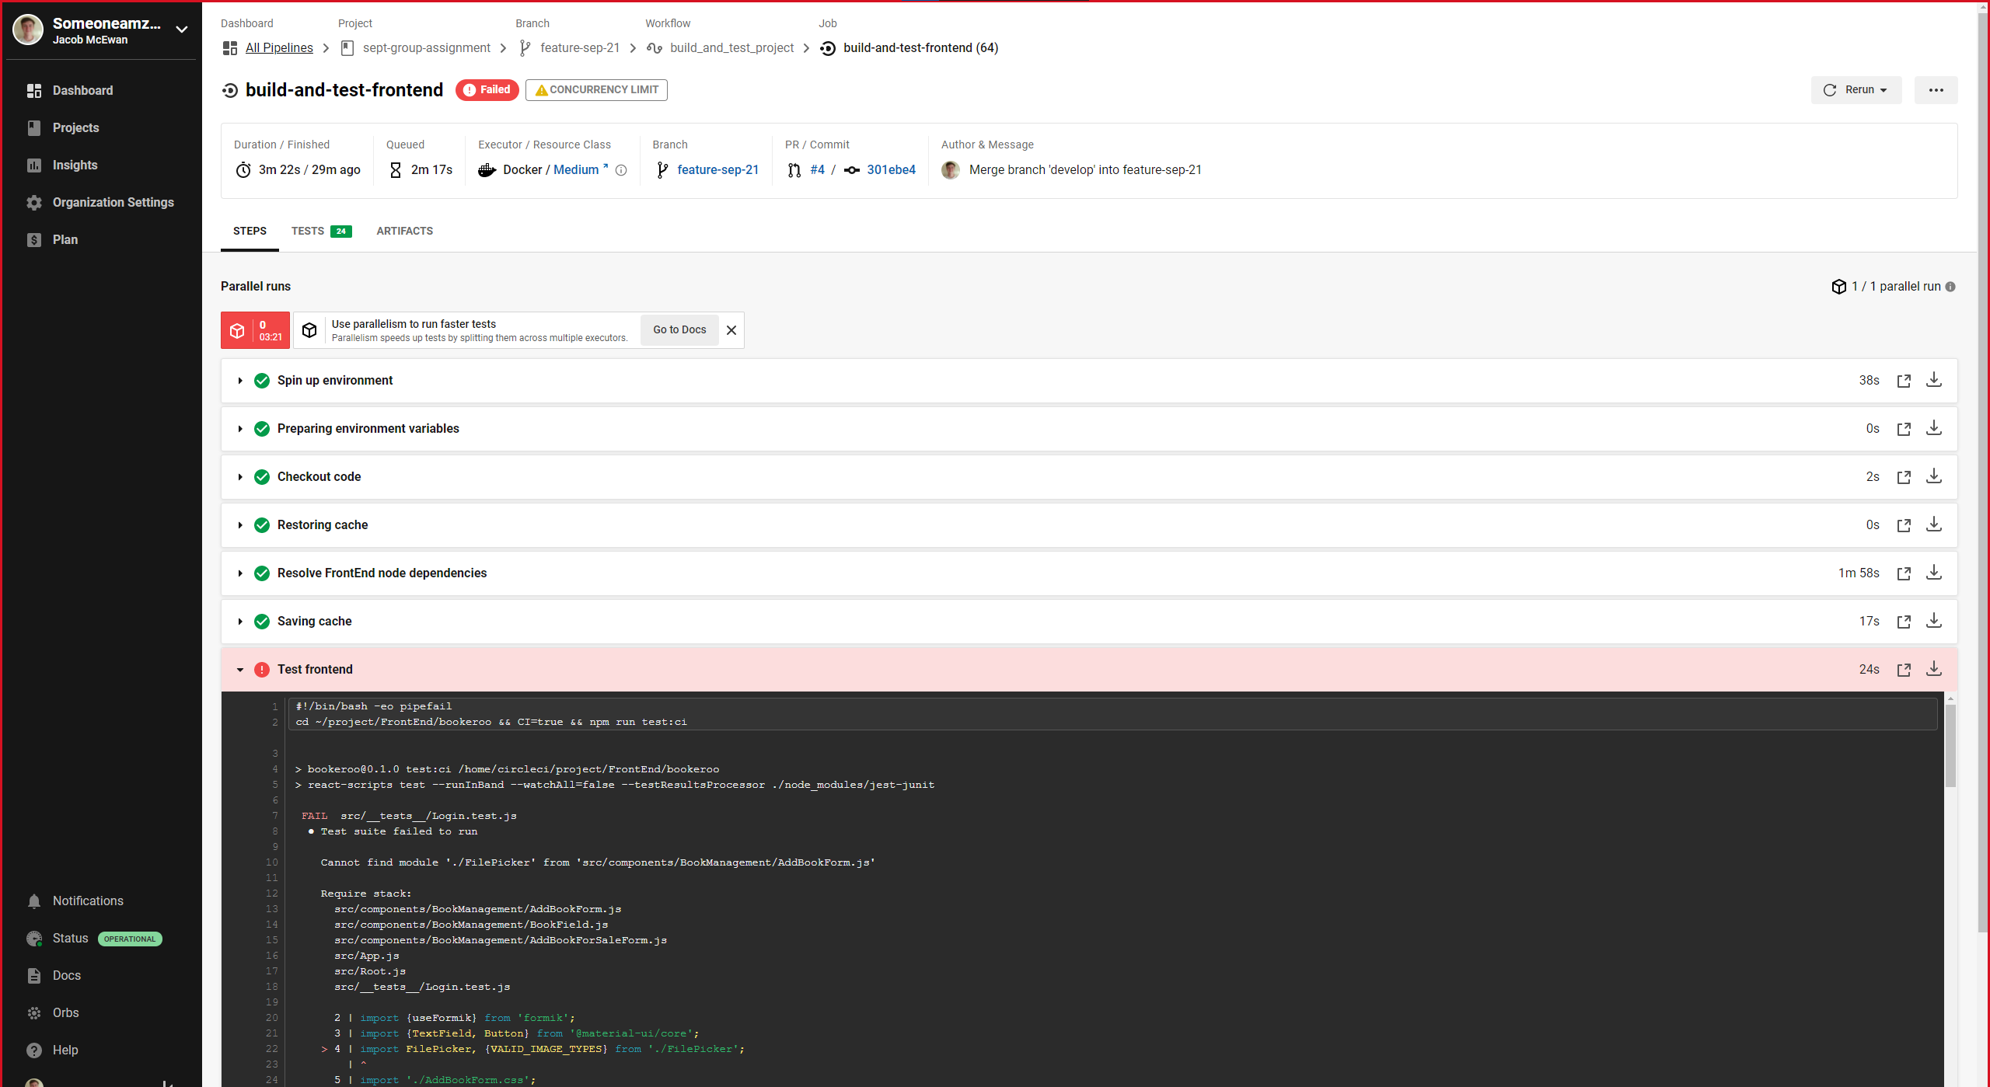

Failed CircleCI test

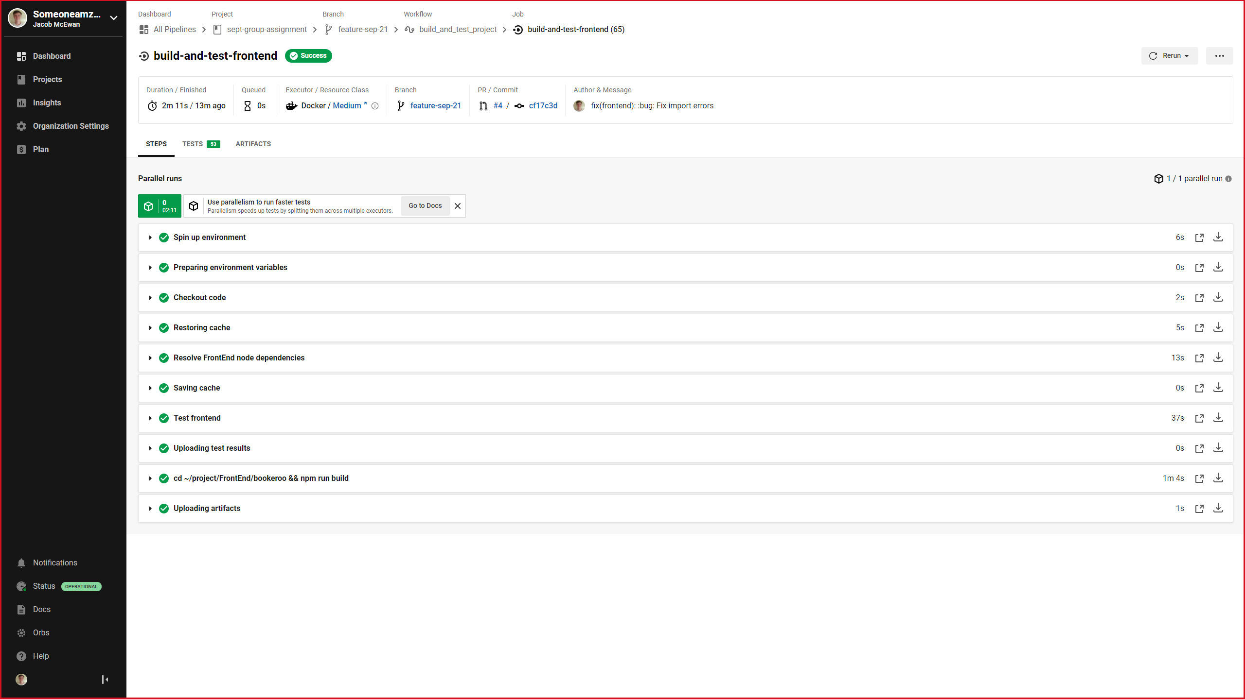

Successful CircleCI Test

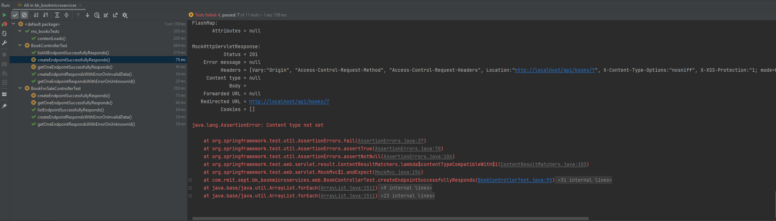

Failed Local Test

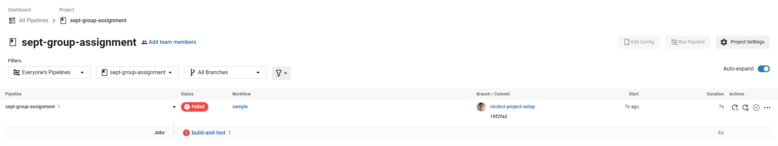

Failed CircleCI Test Summary

**A screenshot of the complete overview of all build attempts on CircleCI is contained in “Docs/Milestone 2/circleci-overview.png”**

# Milestone 2 Release

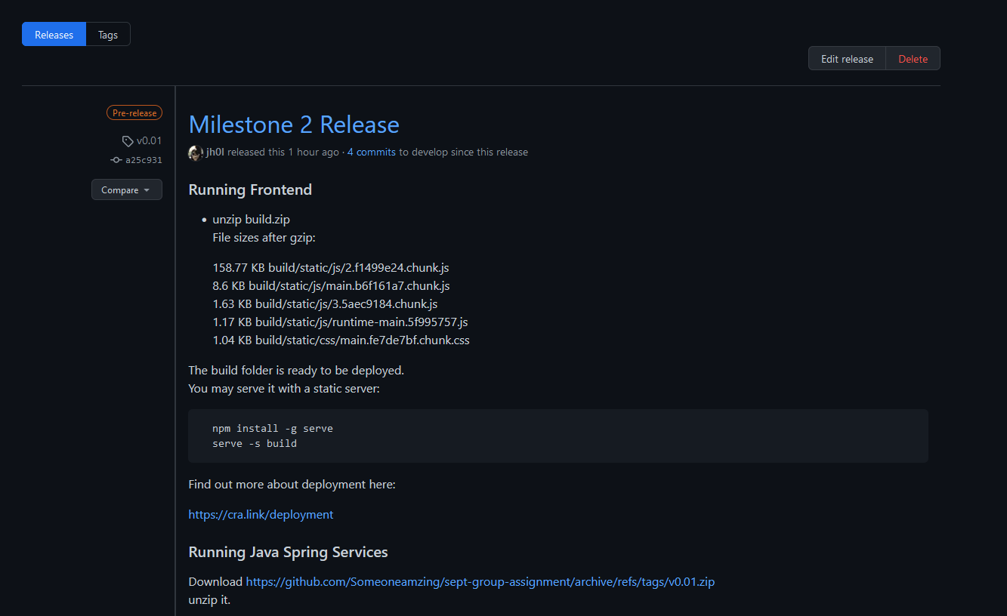

This release contains a build of the frontend which can be run on a deployment with the npm package “serve”.

The Microservices loginmicroservice, and bookmicroservice can be run from source using maven and their respective application configuration files.

There is limited functionality in this release as there are still many features to implement.